**Student Name:- Chaudhary Hamdan**

**Student Roll No.:- 1905387**

**Algorithm Lab. Program Test**

**CSE Group 1**

**Date: - 12th NOV. 2021**

**Program Screen short**

// Author: Chaudhary Hamdan

// Generated at: Fri Nov 12 12:25:14 2021

#include <stdio.h>

#include <time.h>

#include <limits.h>

#include <stdbool.h>

#define sf(x) scanf("%d", &x)

#define pf printf

#define pfs(x) printf("%d ", x)

#define pfn(x) printf("%d\n", x)

#define pfc(x) printf("%d, ", x)

#define FI(i,x,y,inc) for(int i = x; i < y; i += inc)

#define F(i,x,y) FI(i, x, y, 1)

#define F0(i,n) FI(i, 0, n, 1)

#define RF(i,x,y) for(int i = x; i >= y; i--)

#define pfarr(i,a,n) for(int i = 0; i < n-1; i++) pfs(a[i]); pfn(a[n-1]);

void i_o_from_file() {

#ifndef ONLINE_JUDGE

freopen("C:\\Users\\KIIT\\input", "r", stdin);

freopen("C:\\Users\\KIIT\\output", "w", stdout);

#endif

}

/* **************************************************************** */

int V;

int minKey(int key[], bool mstSet[])

{

int min = INT_MAX, min_index;

F0(v, V) {

if (mstSet[v] == false && key[v] < min) {

min = key[v], min_index = v;

}

}

return min_index;

}

int printMST(int parent[], int graph[V][V])

{

int cost = 0;

pf("Edge \tWeight\n");

F(i, 1, V) {

pf("%d - %d \t%d \n", parent[i] + 1, i + 1, graph[i][parent[i]]);

cost += graph[i][parent[i]];

}

pf("\nTotal Cost: %d\n", cost);

}

void primsMST(int graph[V][V])

{

int parent[V];

int key[V];

bool mstSet[V];

F0(i, V) {

key[i] = INT_MAX;

mstSet[i] = false;

}

key[0] = 0;

parent[0] = -1;

F0(cnt, V - 1) {

int u = minKey(key, mstSet);

mstSet[u] = true;

F0(v, V) {

if (graph[u][v] && mstSet[v] == false && graph[u][v] < key[v]) {

parent[v] = u;

key[v] = graph[u][v];

}

}

}

printMST(parent, graph);

}

int main() {

i_o_from_file();

/* ********************************************* */

sf(V);

int graph[V][V];

F0(i, V) {

F0(j, V) {

sf(graph[i][j]);

}

}

primsMST(graph);

pf("\nTime complexity: V²\n");

return 0;

}

**Output Screen short**

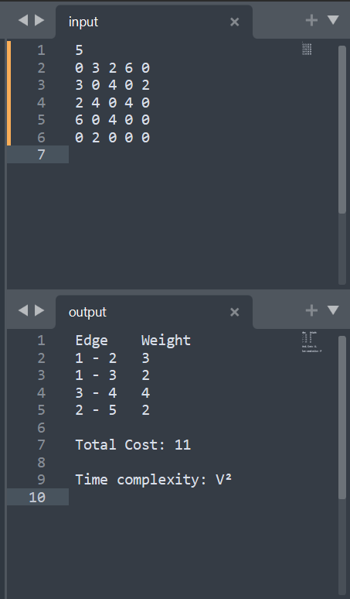

**(Upload the PDF only)**